**Assignment 9**

**Write a query that lists each order number followed by the name of the customer who made the order.**

**Select customers.cname, orders.onum from orders,customers where orders.cnum=customers.cnum**

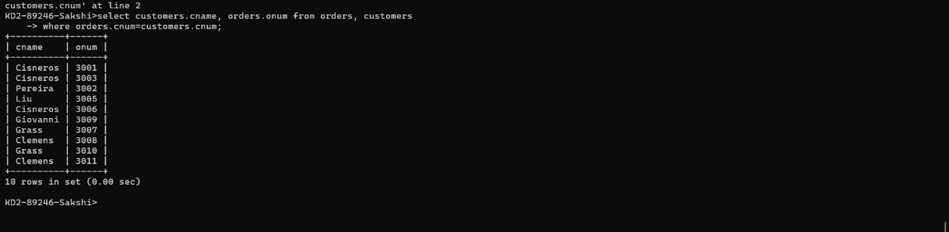

**2) Write a query that gives the names of both the salesperson and the customer for each order along with the order number.**

Select salespeople.sname,customers.cname,orders.onum from orders, customers, salespeople where salespeople.snum=customers.snum and customers.cnum=orders.cnum;

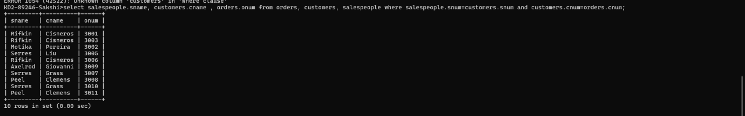

**3) Write a query that produces all customers serviced by salespeople with a commission above 12%. Output the customer’s name, the salesperson’s name, and the salesperson’s rate of commission.**

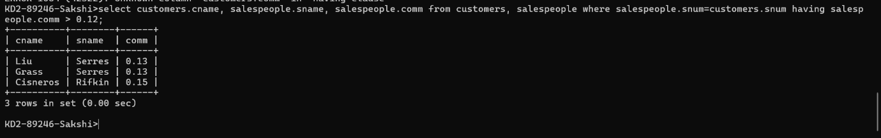

**4) Write a query that calculates the amount of the salesperson’s commission on each order by a customer with a rating above 100.**

